

# SECP1513 – TECHNOLOGY AND INFORMATION SYSTEM

# Supermarket Products Information Application

## Group Members

| **No.** | **Name** | **Matric No.** |
| --- | --- | --- |
| 1 | Ahmed Ali Abdalla Musa | A23CS4036 |
| 2 | Ahmed Mahgoub Saidahmed | A23CS3023 |
| 3 | Eyad Aimen Elsheikh Khalil | A23CS3024 |
| 4 | Moaz Adil Abdugadir Jalal | A23CS3025 |

# Youtube video link: <https://youtu.be/35O-XGyJ1ak>

# Table of Content

**Introduction 2**

**Details of the design thinking process 2**

Stage 1: Empathize 2

Stage 2: Define 3

Stage 3: Ideate 4

Stage 4: Prototype 5

Stage 5: Test 5

**Detailed descriptions include problem, solution and team working 6**

Problem 6

Solution 6

Team Working 6

**Design Thinking Assessment Points 7**

**Reflections 7**

# Introduction

In this report, we will go through the design thinking process of our project. In this project we’re trying to solve an issue that faces many people, the difficulty of reading the products’ information when written in small fonts, this can be a critical issue, especially for people with allergies to specific ingredients. We thought of making a mobile application that can scan the barcode on the product and display its information on the mobile, and allow the users to see if the product includes ingredients that they are allergic to. While working on this project we went through many stages and challenges starting from empathizing, defining the problem, generating ideas, designing a prototype and testing.

# Details of the design thinking process

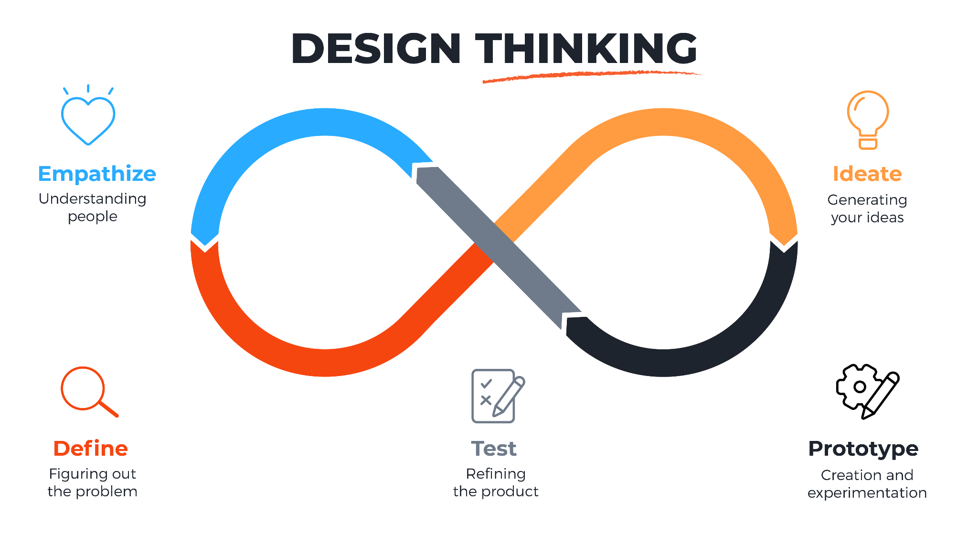

## Stage 1: Empathize

In this stage, we try to understand the users and their needs. By conducting an interview with Ahmed Mohamed Khalid, a 22 years old computer science student who suffers from the difficulty of reading some products’ information and has allergies to some ingredients. This interview helped us figure out the expectations and challenges.

Ahmed Mohamed Khalid informed us about the challenges he faces in reading some products' information when it is written in small fonts.

This phase helped us to gain base information for what to include in our project.

| **Question** | **Ahmed Mohamed Khalid Answer** |
| --- | --- |
| Why do you care about reading the product information? | Because I am allergic to some ingredients and I cannot consume it. |
| How often do you face this problem? | Every time when i go to the supermarket unless i memorize and remember what the ingredients in the product |
| What do you expect from our project? | I expect that you include a way to make these product information easy to read and allow me to list the allergies that I have so that I would know that the product includes these ingredients. |

## 

| Evidence | Conducted an interview with Ahmed Mohamed Khalid who is allergic to some ingredients in supermarket products. |
| --- | --- |
| Team progress | * Figured out the expectations and challenges in the project we want to develop * Identified the overall common problems that the different users face |
| Brainstorm ideas | * Our proposed solution is based on the answers from the interview and *** expectations. * We decided to conduct an analyzing session for the interview results to define the problem. |

## 

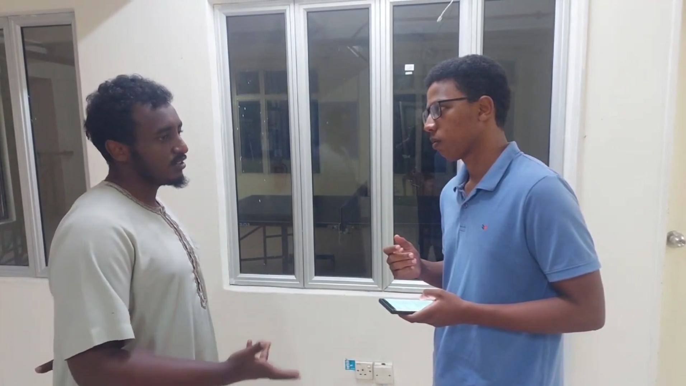

## Stage 2: Define

In this stage, we have defined the problem that we will solve based on the outcomes of the empathy stage. We want to enable the users to read the product information clearly and easily, we also will help them avoid products with ingredients that they are allergic to by outlining them when displaying the product information.

| Evidence | Conducted an analyzing session for the outcomes of the empathize interview. |
| --- | --- |
| Team progress | * Identified the problem statement of the project and related challenges. |
| Brainstorm ideas | * The proposed solution will based mainly on the conducted interview with ***. * We identified the main goals and important features of the project. |

## 

## Stage 3: Ideate

After identifying our users and problems, we begin to think about the solution. After a brainstorming session, we decided to make a mobile application. The application will enable the user to scan the product barcode and then display the product information. Another idea we came up with is to allow the users to enter the ingredients they are allergic to and outline it to them if it was in the ingredients of the product they scanned.

| Feasible Ideas | Infeasible Ideas |
| --- | --- |
| * Scanning the barcode and displaying information. * Adding a list of allergic ingredients for each user and outlining them. * Include a list of nearby supermarkets and the products that they sell so that the user can access the data without going to the supermarket. | * Translating the product information if they are in another language. * Suggest alternative products that don’t contain the ingredients the users are allergic to. |

| Evidence | Conducted an online brainstorming session, used canva whiteboard and each member suggested his ideas. |
| --- | --- |
| Team progress | * Classified the ideas into feasible and infeasible ideas. * The feasible ideas are the main features to be included in the mobile application. * The unfeasible ideas will be used later to improve the mobile application. |
| Brainstorm ideas | * We classified the ideas through voting. |

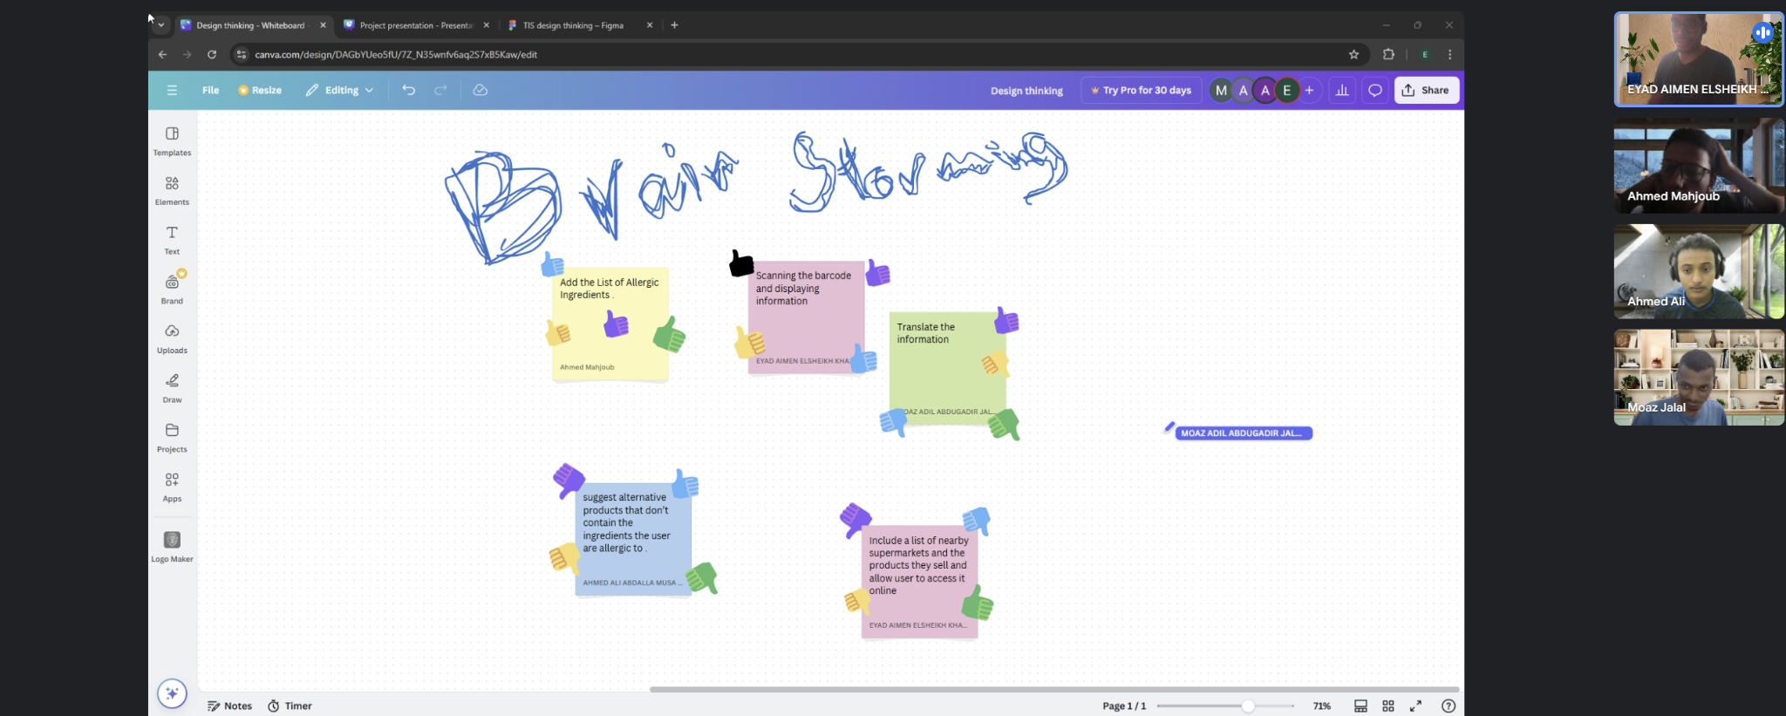

## Stage 4: Prototype

In this stage we designed the prototype, we started making the design prototype using Figma software so we could all participate and share ideas during the designing process. In the end, we came out with the design of the main application screens and its main features.

| Evidence | UI design using figma |
| --- | --- |
| Team progress | * Developed a UI prototype based on the selected ideas |
| Brainstorm ideas | * We decided the theme of our application, the font type, size, and colors used in the application. |

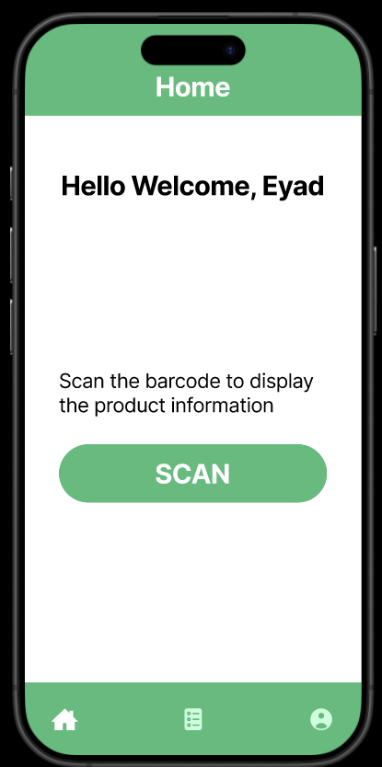 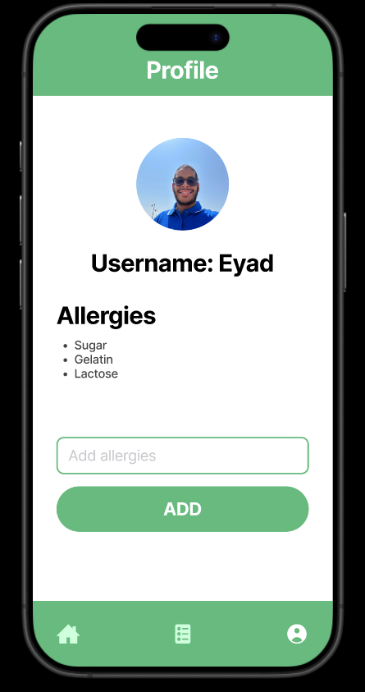

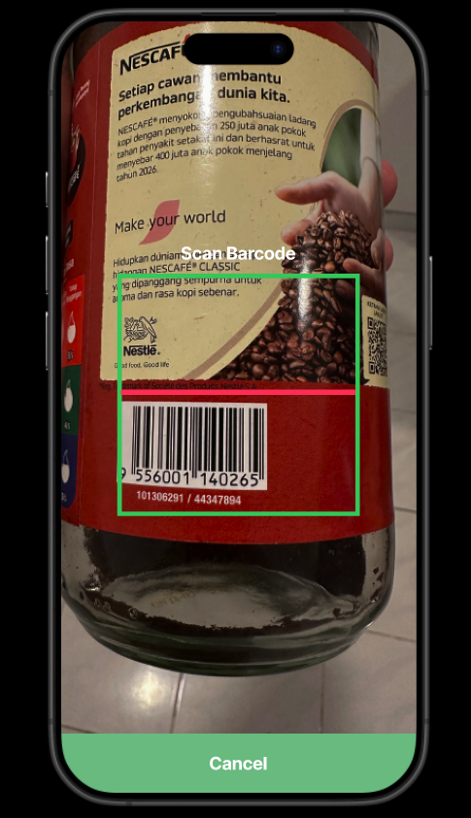 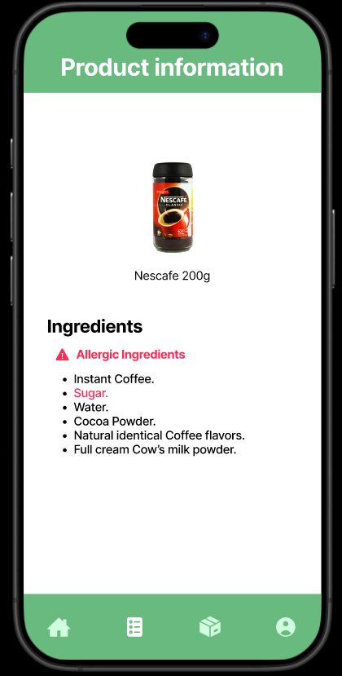

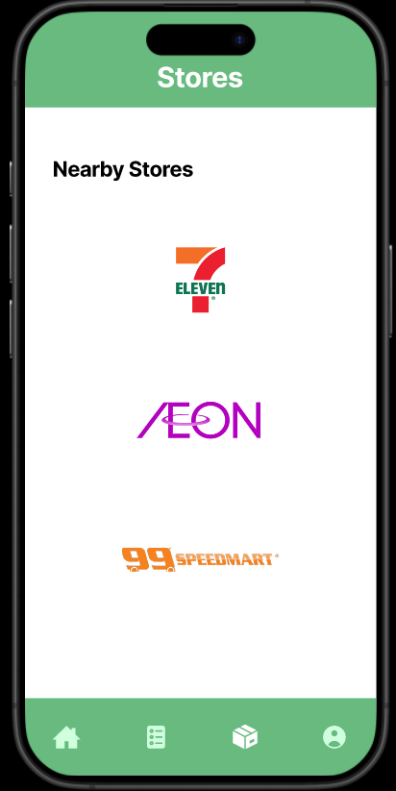 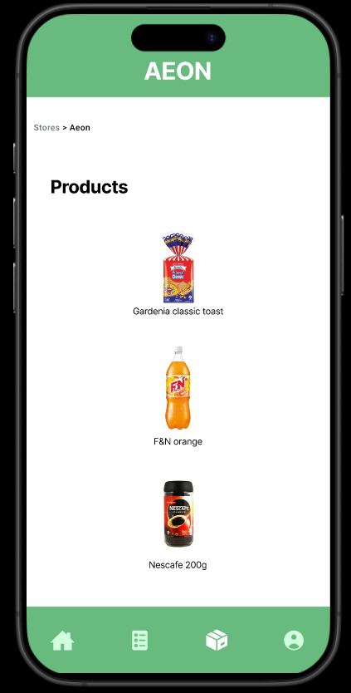

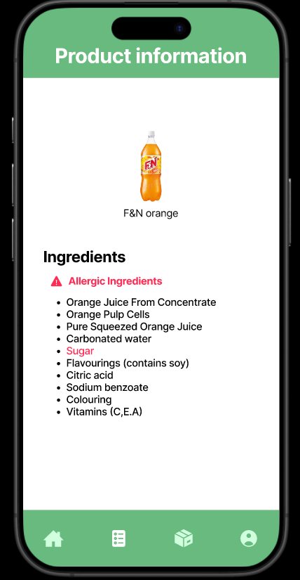

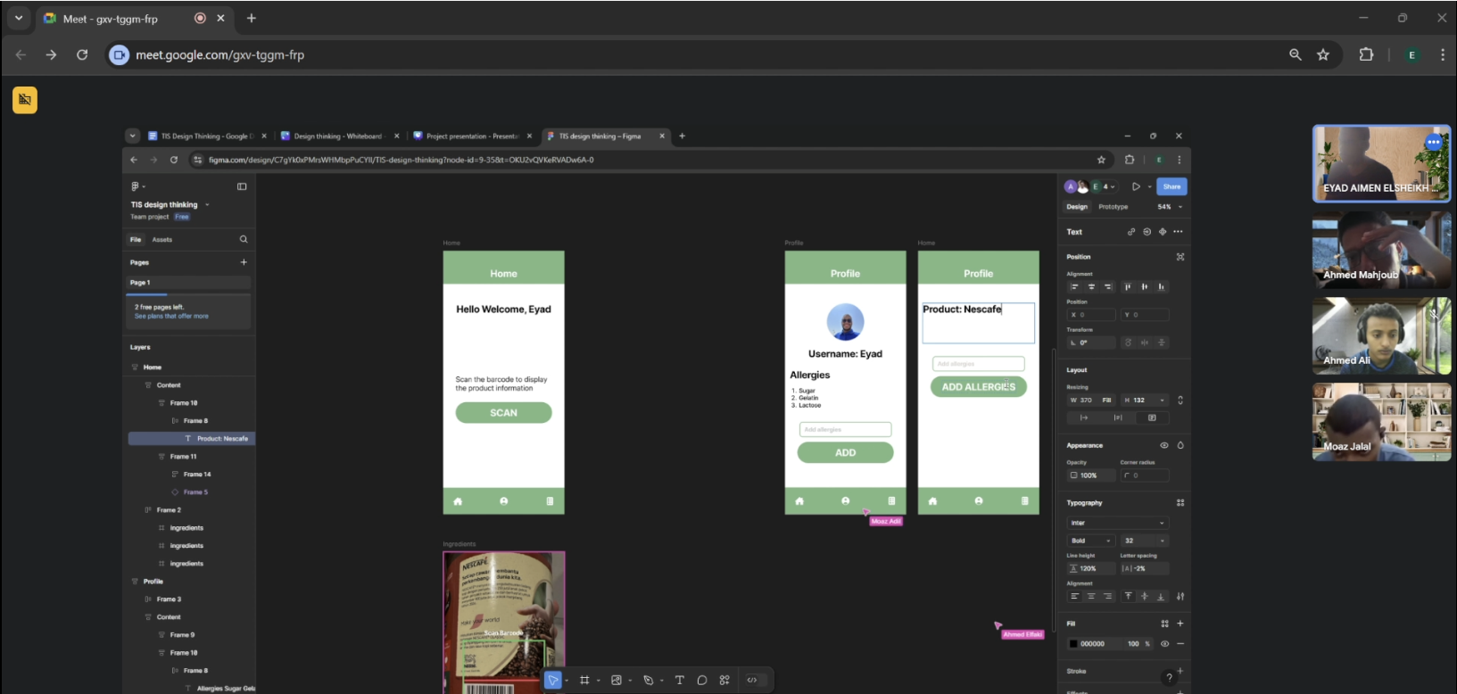

## Stage 5: Test

After designing the prototype, we gave the application for users to test it and gave us their feedback and suggestions. The overall feedbacks were positive, one of the users suggested that we add a history of the scanned product so that the user can access them without having to scan the barcode again, Another suggestion was to add search functionality and scanning barcodes from galleries, One of the suggestions that the project team supported so much was adding a voice reader that reads the ingredients. These feedbacks and suggestions will be great assistance in enhancing and refining the project.

| Evidence | Present the prototype for students and allow them to test it |
| --- | --- |
| Team progress | * Collect users’ feedback and suggestions. |
| Brainstorm ideas | * Discuss the possibility of including the ideas suggested by the users. |

# 

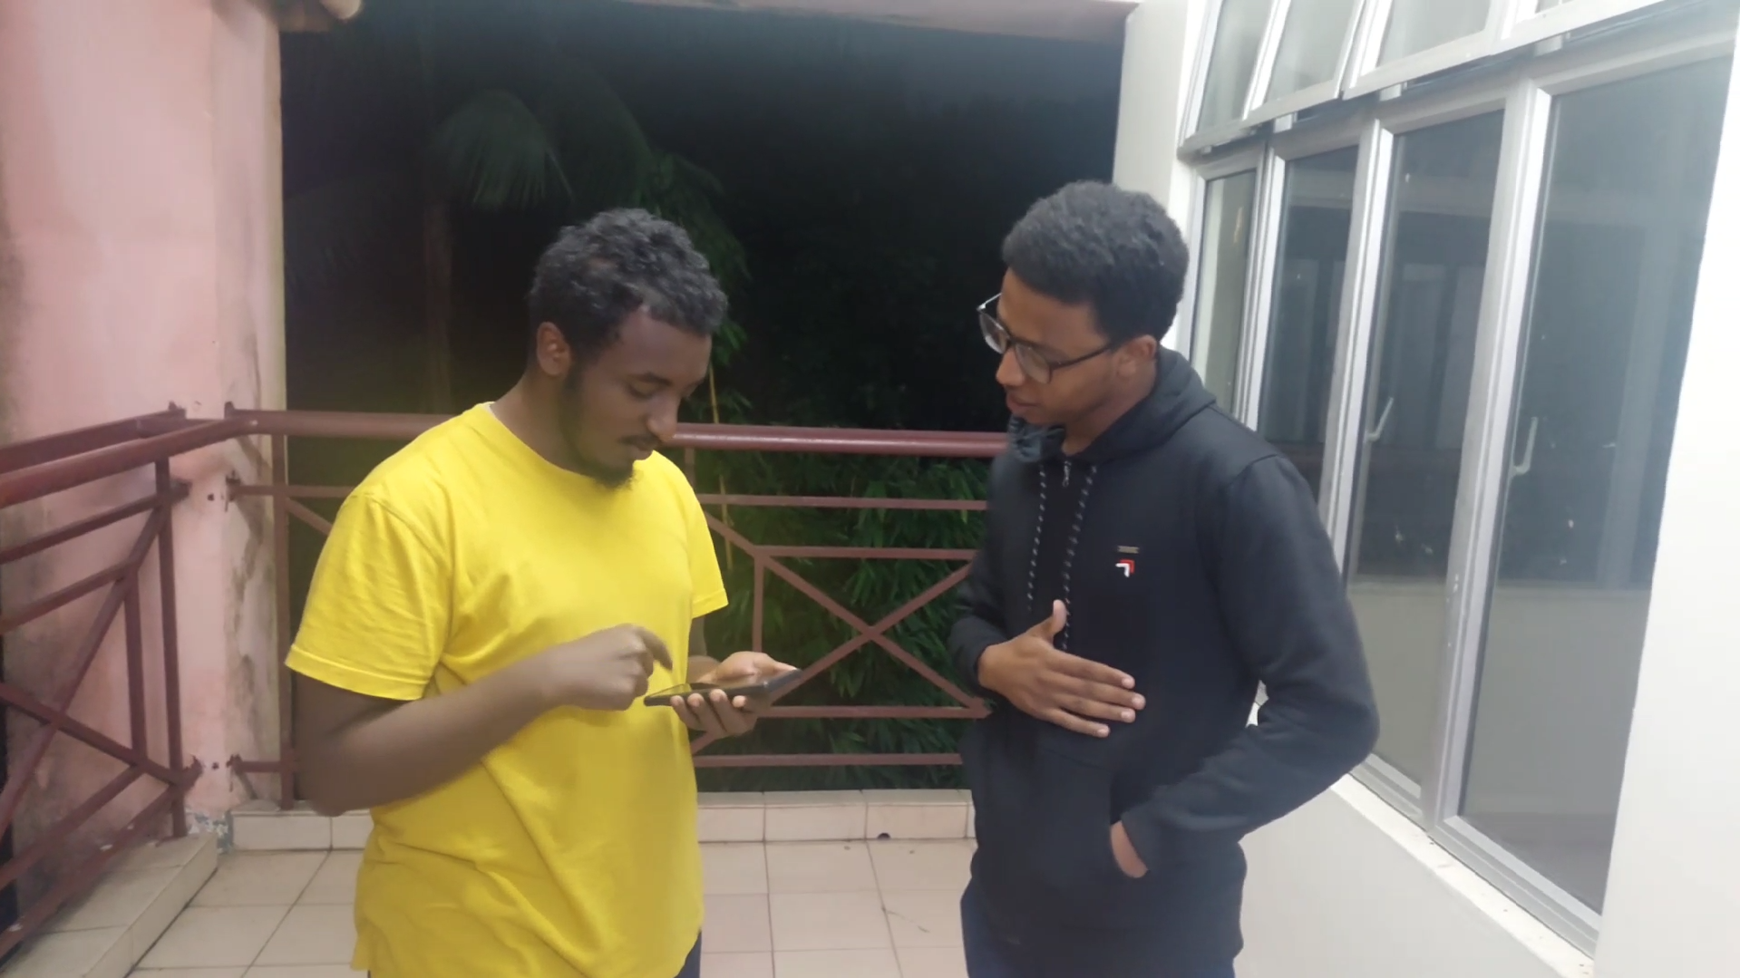

# 

# Detailed descriptions include problem, solution and team working

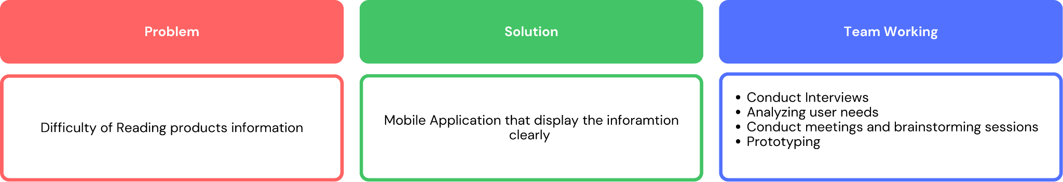

## Problem

The difficulty of reading the products information when written in very small font size, what can be a major issue for people who are allergic to some ingredients, this difficulty can lead them to ask help from other people, discard the product or even consume it without noticing the present of the ingredient they’re allergic to.

## Solution

A user-friendly mobile application that allows the users to scan the product barcode and then display the ingredients of the product clearly, the application will also enable the users to enter the list of ingredients they are allergic to and notify them if it’s available in the product. This solution will ensure the users ability to easily recognize the ingredients of the product.

## Team Working

Through this design thinking project, our team has done several activities and tasks. Our work was characterized by collaboration. The activities that we have done through this project are interviews, meetings, brainstorming sessions, prototyping and feedback collecting.

| **Date** | **Activity** |
| --- | --- |
| 5 Nov 2024 | Meeting to think about a problem to solve. |
| 18 Nov 2024 | Interview with a user to emphasize the problem. |
| 18 Nov 2024 | Meeting to analyze the interview and define the problem |
| 20 Nov 2024 | Submit and present the project proposal |
| 4 Dec 2024 | Brainstorming meeting to come out with a solution |
| 18 Dec 2024 | Brainstorming meeting to come out with ideas for the prototype |
| 31 Jan 2024 | Develop the prototype |
| 1 Jan 2025 | Users test the prototype and collect feedback |
| 4-5 Jan 2025 | Complete the project report |

# 

# Design Thinking Assessment Points

1. Empathy:

In the empathy phase Ahmed Mohamed Khalid gave us clear information about his needs and it was relevant to our project. From this phase we expect to define a problem statement based on the empathy phase. For the challenges is when we discover a problem later that is important and we need to do further interviews to get more insights from different users.

1. Define:

The problem statement we defined in this phase was clear and it is aligned with the

outcome of the empathy phase.

1. Ideate:

In this phase we listed the ideas in 2 categories and defined an idea as feasible using voting. The ideas are aligned with our user expectations and project goals.

1. Prototype:

The prototype we designed reflects the ideas we defined in ideate phase, and this prototype is usable and complete. This prototype also reflects the user's expectations.

1. Testing:

After we finished designing the prototype we let the users test the prototype. They were happy and provided positive feedback. Also, they provided us with good suggestions to consider in the future.

# Reflections

**Ahmed Ali Abdalla Musa**

This program made me able to identify problems and find solutions for them in many fields . also helped me to get a lot of experience as a software engineering student . It helped me learn skills of communicating with the community .The program improved my teamwork skills .

**Ahmed Mahgoub Saidahmed**

This program has really been instrumental in providing me with the skills and the knowledge required to identify diverse challenges related to Technology and Computer science fields. It enabled me to determine the major problems that face our society and affect its technological growth. And then use a structured approach to gather information that will lead to the best solution that can address the problem. The design of the solution will highly depend on my creativity and the approach that I follow in information’s Elicitation process.

Nevertheless this project has equipped me with multiple skills, designing the prototype for example was really joyful, also this program helped me alot when it comes to team working since I did everything after a series of discussions with my creative teammates .

Lastly I will never forget this experience since it was really inspiring and impactful on me in order to provide help to some people in our society who are in a severe need for solutions like this.

**Eyad Aimen Elsheikh Khalil**

This program helps me to achieve my dream by becoming able to solve different problems in different tech industries by providing me a good base knowledge about the multiple fields in the computer science industry. The design thinking made a good impact on me by discovering why team communication is important, the project needs good planning before starting developing it, and why it is important to communicate and get feedback from the users that are going to benefit from the software product that I will develop in the future. To improve my skills and potential in the industry I have to not rely on the university only but use the learned concepts, enhance and enrich it so that I can benefit the most from it, also develop projects on my own and get some feedback from the people that will use it to improve my skills.

**Moaz Adil Abdugadir Jalal**

My goal in this program is to become a reliable software engineer that can solve real problems and be able to develop helpful systems and applications. This design thinking project helped me by introducing the appropriate steps of identifying and solving a problem and how to collaborate with others to overcome challenges. In order to improve my potential I aim to participate in academic and non-academic activities, also I need to improve my presentation skills.

# 

# 

# 

# Task for each member:

| **Task** | **Member** |
| --- | --- |
| Problem proposal | Ahmed Mahgoub |
| Interview | Ahmed Mahgoub  Ahmed Ali |
| Problem statement and proposed solutions | All members |
| Prototype draft | Moaz Adil |
| Develop prototype | All members |
| Finishing the report | Eyad Aimen  Moaz Adil |
| Video | Eyad Aimen |

# 

# References

<https://www.maqe.com/insight/the-design-thinking-process-how-does-it-work/>